

**INDIAN INSTITUTE OF INFORMATION TECHNOLOGY**

**VADODARA**

**IT-301 SOFTWARE ENGINEERING**

Team IT - 05

Mentor : Dr. Asim Banerjee

**Web Development**

UI Design Layouts

Version 1.0

**Version History:**

|  |  |  |  |
| --- | --- | --- | --- |
| Version | Date | Author | Reviewer |
| v1.0 | **03-10-2017** | **Akriti Bhadoriya**  **Chetanya Shrimali** |  |

**Team Members:**

|  |  |
| --- | --- |
| Name | E-mail |
| Akriti Bhadoriya | [201552074@iiitvadodara.ac.in](mailto:201552074@iiitvadodara.ac.in) |
| Anshit Kumar | [201552056@iiitvadodara.ac.in](mailto:201552074@iiitvadodara.ac.in) |
| Niranjan Choudhary | [201552060@iiitvadodara.ac.in](mailto:201552074@iiitvadodara.ac.in) |
| Chetanya Shrimali | [201552064@iiitvadodara.ac.in](mailto:201552074@iiitvadodara.ac.in) |
| J Manikanta Swamy | [201552068@iiitvadodara.ac.in](mailto:201552074@iiitvadodara.ac.in) |
| Vamshi Krishna | [201552079@iiitvadodara.ac.in](mailto:201552074@iiitvadodara.ac.in) |

# Purpose

To describe the user support which should be built-in to user interfaces and to introduce usability attributes and system approaches to system evaluation.

## 

## 

## 

## 

## 

## 

## 

## 

## 

## 

## 

## 1.1 Home Page

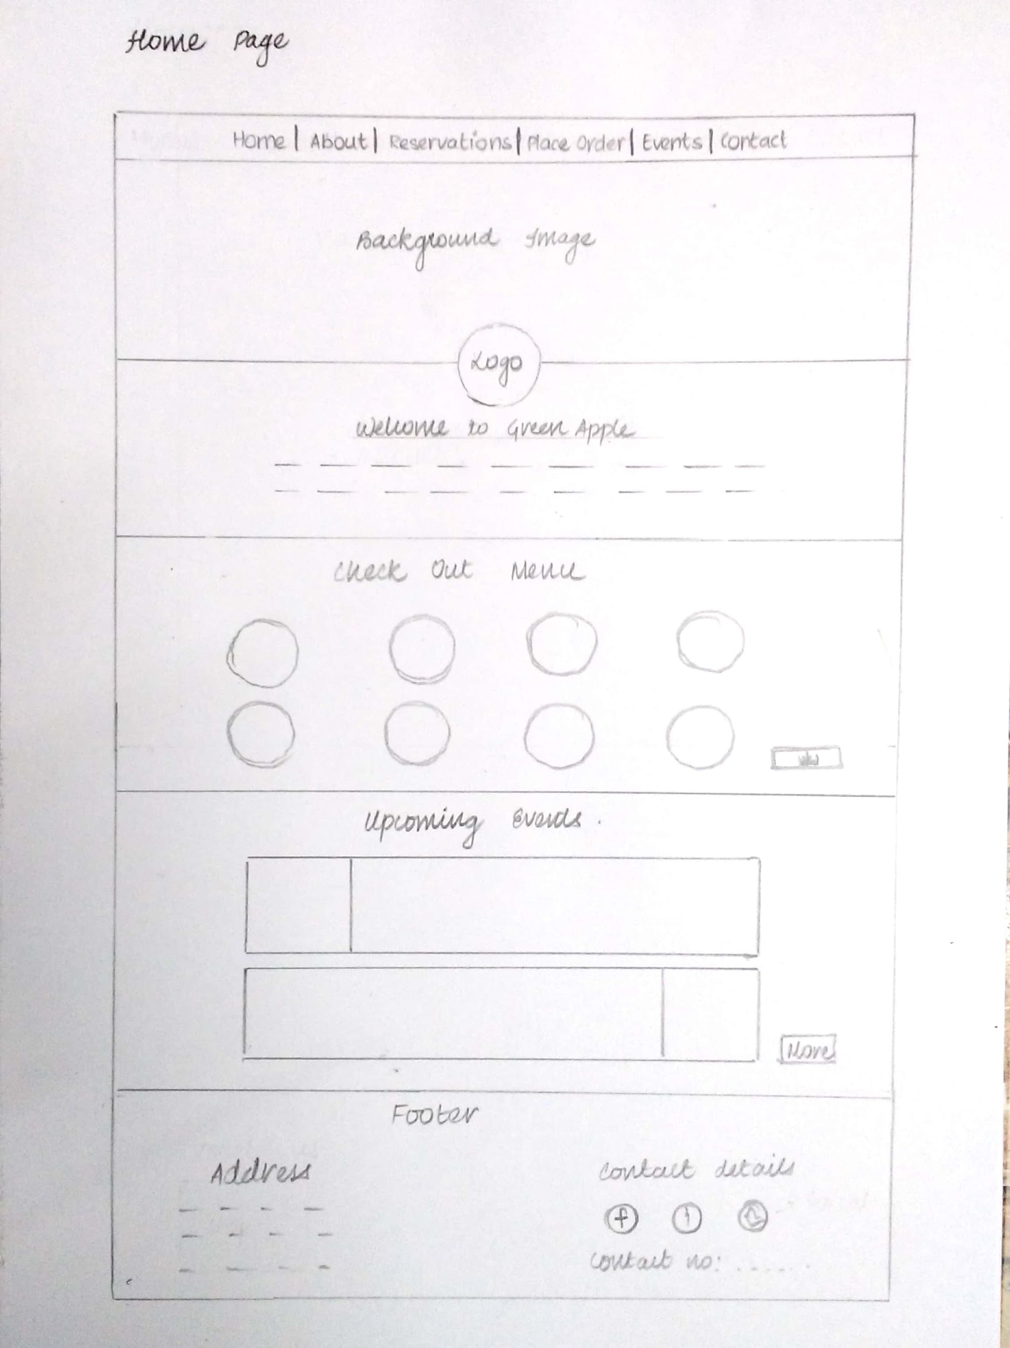

1.2 About us

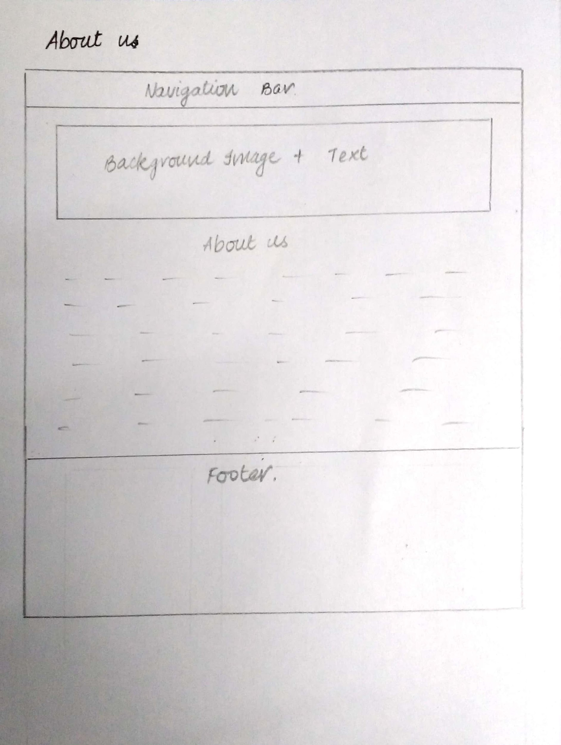

## 1.3 Reservations

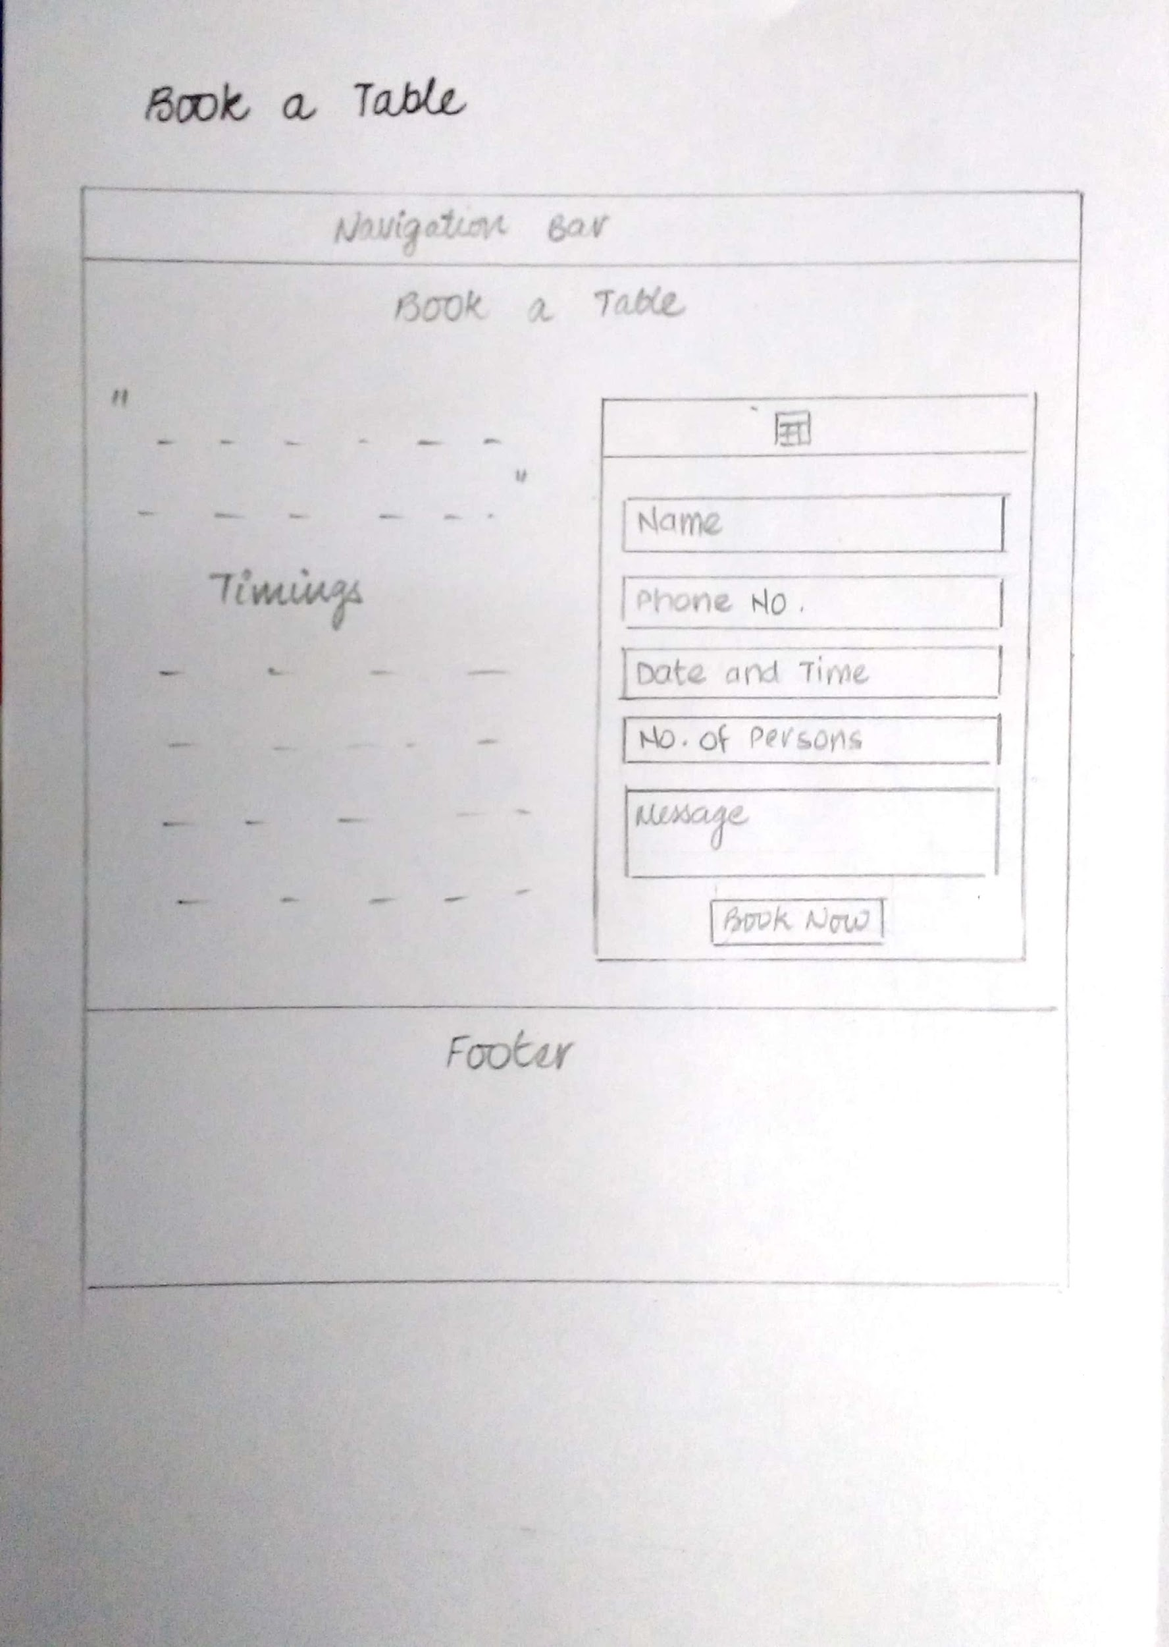

## 1.4 Order Online

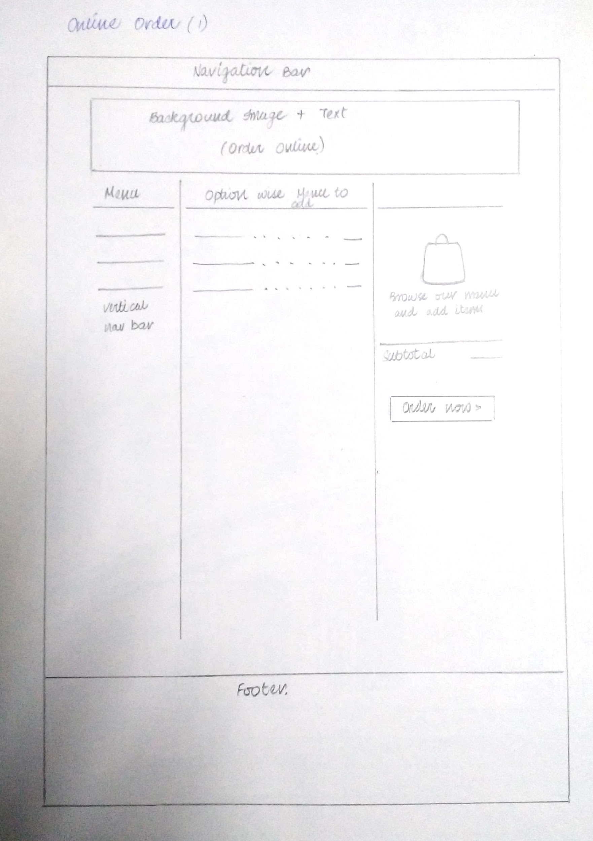

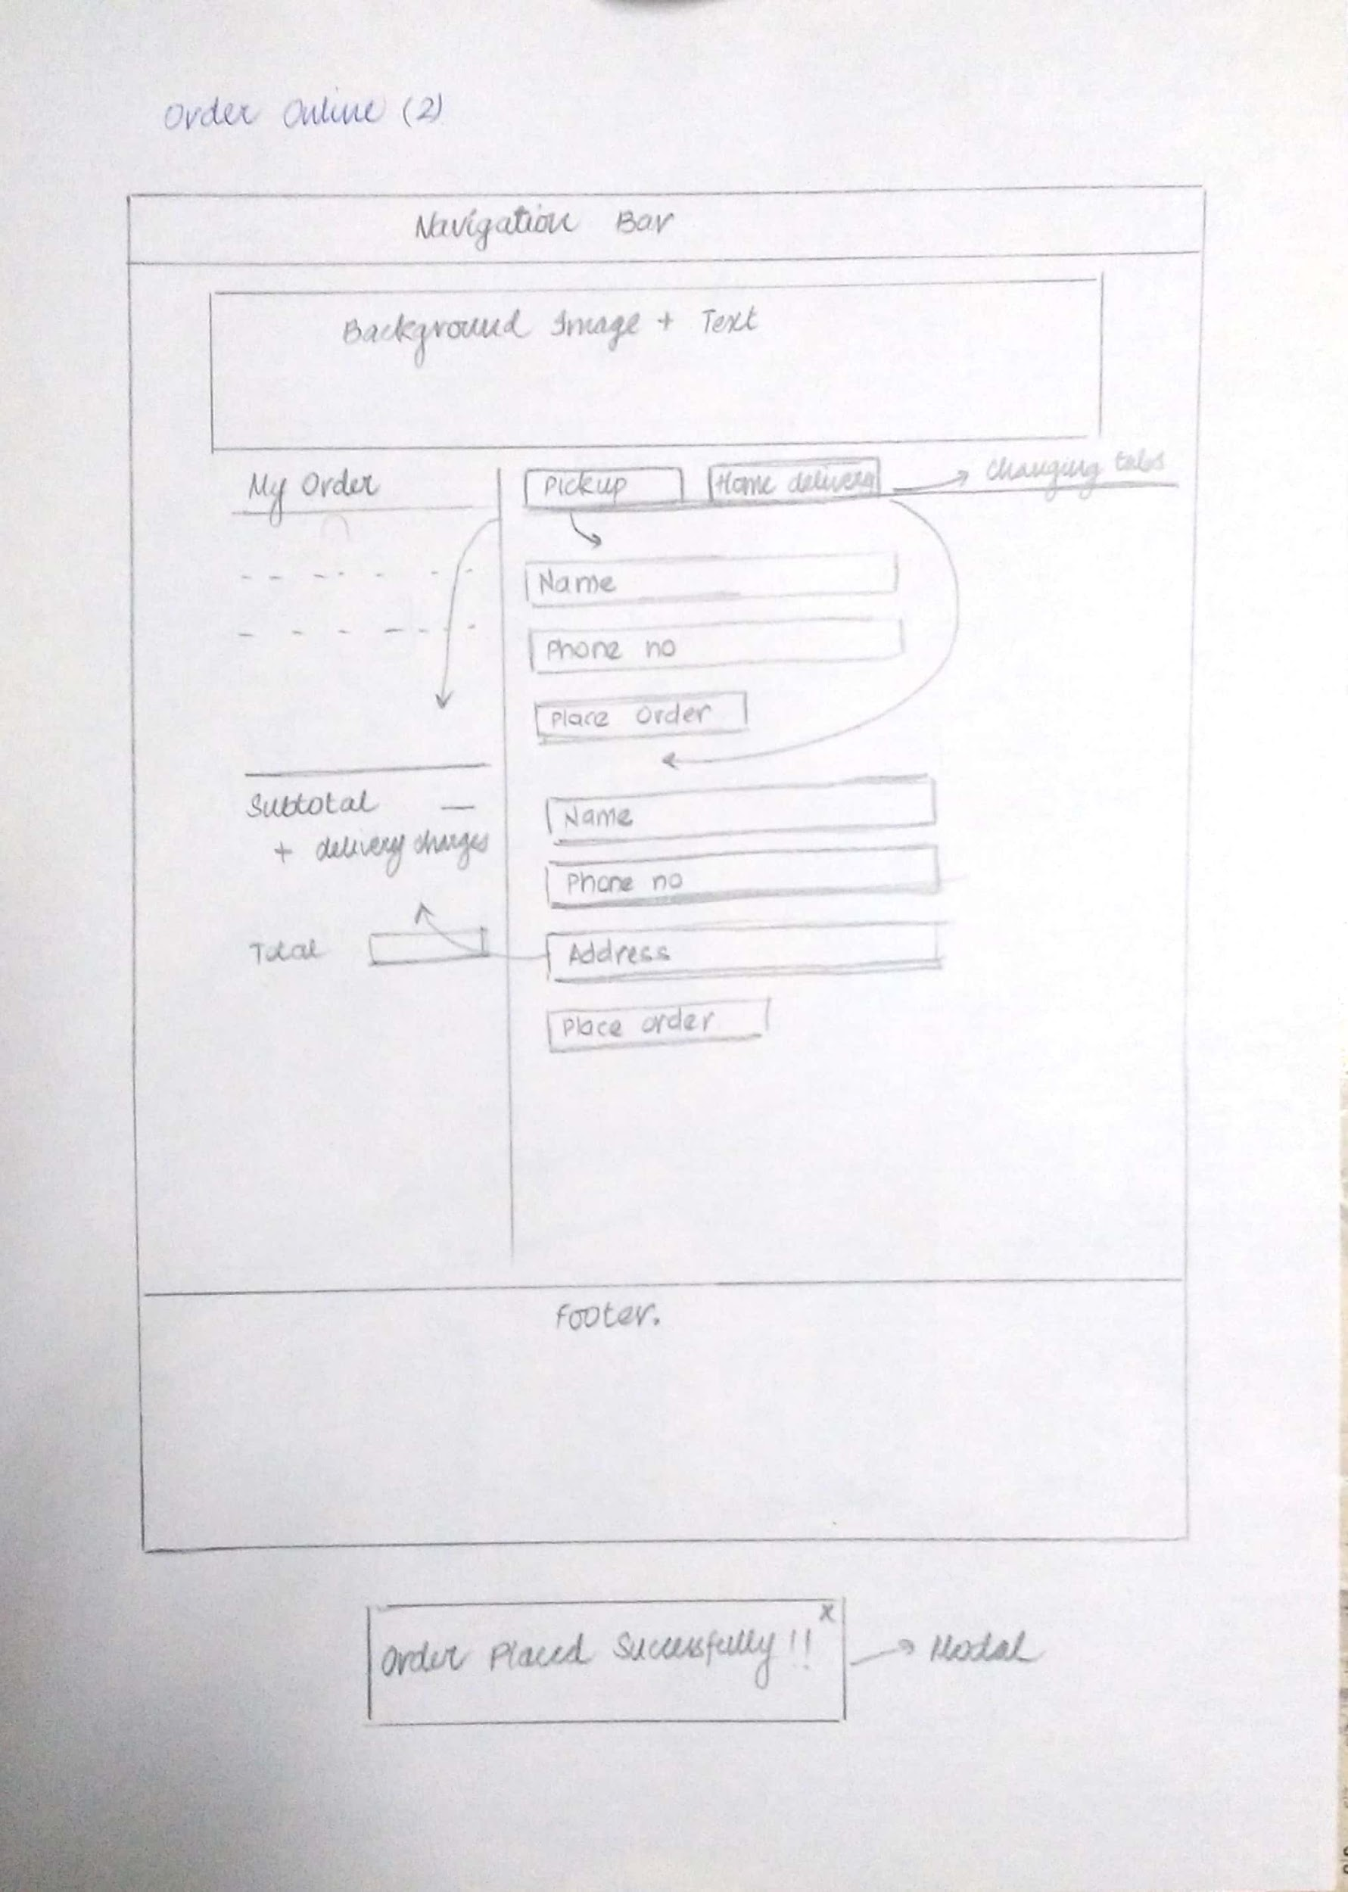

## 1.6 Our Events

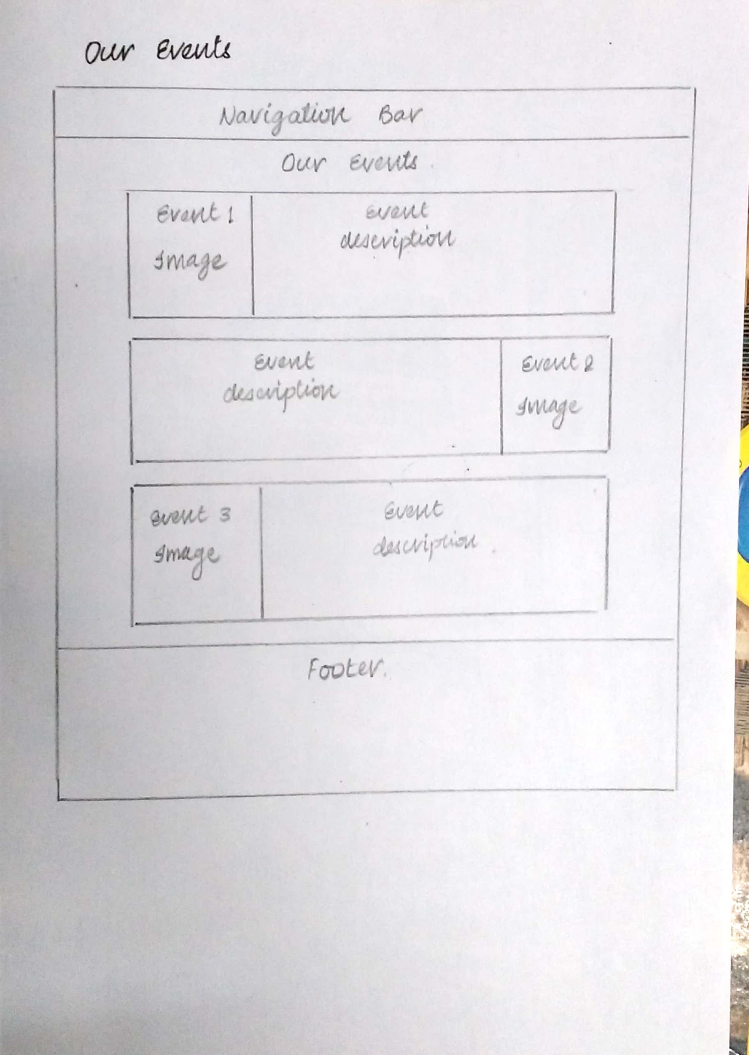

## 1.7 Contact Us

